Keycloak - Version 17.0.1  
Keycloak : phân quyền & xác thực người dùng.

Download from: https://github.com/keycloak/keycloak/releases/download/17.0.1/keycloak-17.0.1.zip

Script to install:

1 unzip in window & transfer to a folder server.

2 cd keycloak/bin

3 chmod +x *

4 nohup ./standalone.sh -b 0.0.0.0 -bmanagement 0.0.0.0 -Djboss.socket.binding.po rt-offset=100 & > log.txt &

-- allow remote device can access to <http://ip:port> & <http://ip:port/auth/admin> and **usage from applications**

--100 mean default **port(8080) + 100**

-- write log to file: **log.txt**

5 add **user admin:** ./add-user-keycloak.sh -u admin (*)

7 reload keycloak: ./jboss-cli.sh --controller=localhost:10090 --connect command=:reload

8 Check result:

* access inbrowser: http://ipserver:8180/auth/admin
* login by admin acc from (*)
* create a realm: IoT-HP
* d in Iot-HP realm
  + create 1 user: iot_user
* From the left menu: create 1 client to get **client_id** and **client_secret, fill out these infos:**

9 config DB: keycloak/configuration/standalone.sh

Check section: **datasource**

* 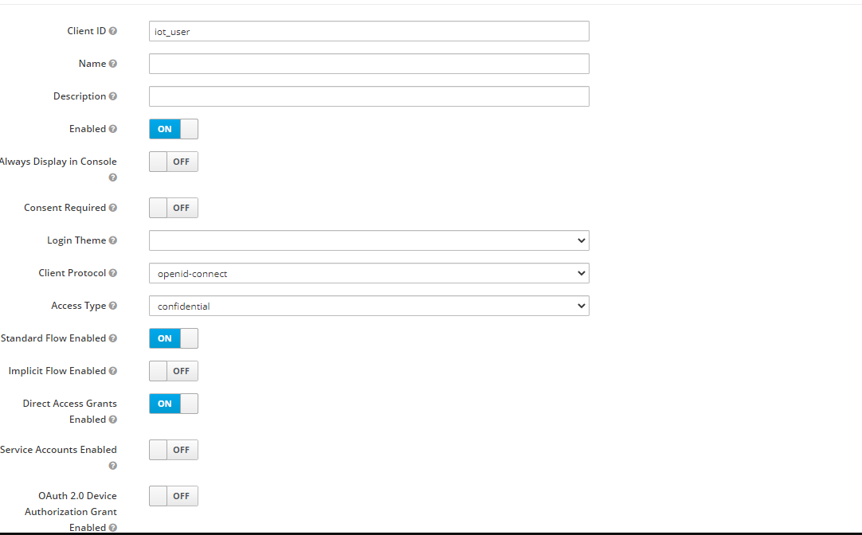

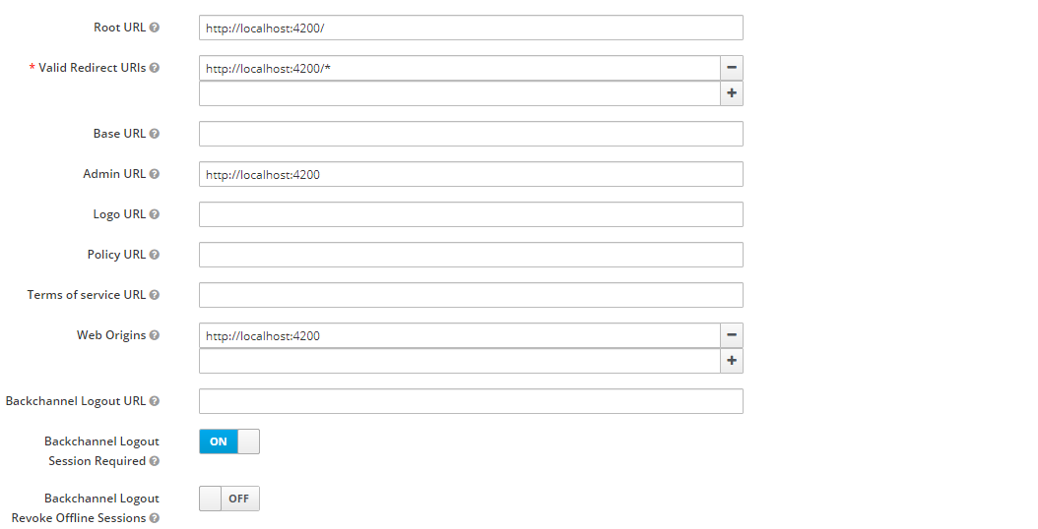

* Pay attention to slash (/*) from url link above, some have, some does not have

In application backend:

keycloakverify.url = <http://10.60.110.22:8200/auth/realms/IoT-HP/protocol/openid-connect/token>

keycloak.realm=IoT-HP

# client_id  
keycloak.resource=iot_user  
keycloak.auth-server-url=http://10.60.110.22:8180/auth  
keycloak.ssl-required=none

In application front-end:

CLIENT_ID: 'iot_user',  
CLIENT_SECRET: 'cOHfExZJlrRAVd2Z7D053wV3EIq7Cful',

**Some common cmd:**

vi /home/app/keycloak/keycloak-17.0.1/standalone/configuration/keycloak-add-user.json --check user info created

./jboss-cli.sh --controller=localhost:10090 --connect command=:reload -- restart keycloak

./jboss-cli.sh --controller=localhost:10090 --connect command=:shutdown –shutdown keycloak

Nohup ./standalone.sh -b 0.0.0.0 -bmanagement 0.0.0.0 -Djboss.socket.binding.po rt-offset=100 & > log.txt & -- start keycloak

./add-user-keycloak.sh -u admin -- add **user admin**